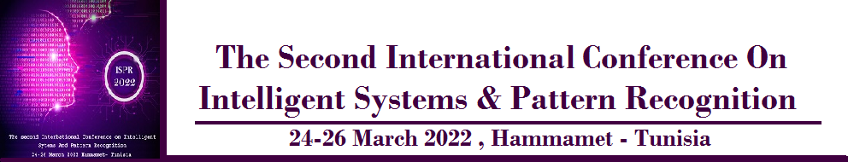
First CALL FOR PAPERS
======================================================================

The Second International Conference on Intelligent Systems and Pattern Recognition
24-26 March Hammamet, Tunisia
https://ispr2022.sciencesconf.org/
It is a pleasure to share with you that the second edition of the international conference on Intelligent Systems and Pattern Recognition (ISPR’2022) will be held in Hammamet, Tunisia, on 24-26 March 2022.
ISPR is an international conference bringing together researchers and aims to provide an opportunity for them to meet, discuss and share the recent advancements, latest solutions, scientific results and methods in solving intriguing problems in the field of intelligent systems and pattern recognition.
Subject areas include all the current fields of interest represented by the Technical Committees of the International Association of Pattern Recognition, and other developing themes involving learning and recognition.
Examples include :
Track 1: Artificial Intelligence
- Natural language processing
- Knowledge representation and reasoning
- Constraint processing and heuristic search
- Intelligent interfaces
- Multi-agent Systems
- Machine Learning
- Deep learning
- Data Mining
Track 2: Pattern Recognition
- Document Analysis
- Handwriting analysis and recognition
- Pattern recognition & applications
- Image, speech, signal and video processing
- Biometrics applications
- Computer vision, Robotics and perception,
- Virtual reality and medical applications
The conference programme will include regular paper presentations in parallel tracks, along with prominent keynote speakers. All submitted papers will be reviewed by experts in the field based on the criteria of originality, and significance,
Authors are invited to submit original, previously unpublished research papers, proposing novel solutions or describing particular challenges or experiences relevant to the scope of the conference.
Submitted papers must not be currently under review by any other conference or journal.
IMPORTANT DATES
Submissions deadline : December 31, 2021.
Authors Notification: January 31, 2022.
Registration and Final manuscript due: February 28, 2022.
Conference Dates: March 24 to 26, 2022.
Papers must be submitted electronically using online submission system by December 31sh, 2021.

All submitted papers will be reviewed by at least 3 members of the international program committee; additional reviewers will be consulted if needed. Paper acceptance will be based on originality, significance, technical sou
For any problem in the submission process, please, send an email to: ISPR2022@easychair.org or ispr2022@sciencesconf.org
All submitted papers will be reviewed by at least 2 members of the international program committee; additional reviewers will be consulted if needed. Paper acceptance will be based on originality, significance, technical soundness, and clarity of presentation.
IAPR Ethical Requirements for Authors
The IAPR requires that all authors wishing to present a paper declare that:
- The paper is substantially original and that no paper substantially similar in content has been submitted or will be submitted to any other conference or journal during the ISPR 2022 review period.
- The paper does not contain any plagiarism.
- The paper will be presented by the author or a co-author in person.
The IAPR retains the right to eliminate any papers in violation of these requirements and to exclude the authors of such papers from future IAPR community activities.
For the full statement of IAPR ethical requirements for authors see link: http://www.iapr.org/constitution/soe.php.
Submission of the paper implies agreement of the author(s) to attend the conference and present the paper if accepted. We reserve the right to exclude papers accepted but not presented from the conference proceedings submitted for archiving and indexing.
The international conference on Intelligent Systems and Pattern recognition is endorsed by the International Association for Pattern Recognition "IAPR"

All accepted papers of ISPR2020 will be published by the an International Conference Proceedings Series ( Final approval waiting ), and will be will be indexed by several international indexes.
The Three top best papers will be honored by the " IAPR Best Papers Award ".
Moreover, selected authors will be invited to elaborate on their research topic and submit the results for review and potential publication to several International indexed jornals including but not limited to
- The International Journal of Computer Applications in Technology (IJCAT), indexed & listed in mor than 28 index and databases including: Scopus (elsivier), DBLP, google Scholar, ACM, EBSCO, Inspect ...Etc.
- International Journal of Information Systems in the Service Sector (IJISSS), Web of Science Emerging Sources Citation Index (ESCI), SCOPUS, Compendex (Elsevier Engineering Index), INSPEC and 15 more indices.
Best Regards
ISPR’2022 Chair
Akram Bennour

